**8. CREATING SPLASH SCREEN**

**AIM:**

To creating Splash Screen using Mobile Application.

**ALGORITHM:**

**Step 1**: Create a new activity, SplashActivity, to serve as the splash screen.

**Step 2**: Design the layout for the splash screen. You can create a new XML layout file (e.g.,

 splash_activity.xml) or use the existing activity_main.xml. Include any branding

 elements (like a logo) or text.

**Step 3**: In the AndroidManifest.xml, set SplashActivity as the launcher activity by defining it

 with an intent filter for MAIN and LAUNCHER.

**Step 4**: In SplashActivity.java, use setContentView() to link to the splash screen layout.

**Step 5**: Use a Handler to create a delay in onCreate(), which allows

 the splash screen to be displayed for a set duration.

**Step 6**: After the delay, create an Intent to transition from SplashActivity to MainActivity, and

 call startActivity() to launch the main activity.

**Step 7**: Call finish() in SplashActivity to remove it from the back stack, ensuring that the user

 cannot return to the splash screen after it transitions to the main activity.

**Step 8**: Stop the Process.

**COIDNG:**

**activity_main.xml :**

<?xml version="1.0" encoding="utf-8"?>

<RelativeLayout xmlns:android="http://schemas.android.com/apk/res/android"

    android:layout_width="match_parent"

    android:layout_height="match_parent">

    <TextView

        android:layout_width="wrap_content"

        android:layout_height="wrap_content"

        android:text="Main Activity"

        android:layout_centerInParent="true"

        android:textSize="24sp" />

</RelativeLayout>

**AndroidManifest.xml :**

<manifest xmlns:android="http://schemas.android.com/apk/res/android"

    package="com.example.splashscreenapp">

    <application

        android:allowBackup="true"

        android:icon="@mipmap/ic_launcher"

        android:label="@string/app_name"

        android:roundIcon="@mipmap/ic_launcher_round"

        android:supportsRtl="true"

        android:theme="@style/Theme.AppCompat.Light.DarkActionBar">

       <activity

            android:name=".SplashActivity"

            android:exported="true"> <!-- Specify exported attribute -->

            <intent-filter>

                <action android:name="android.intent.action.MAIN" />

                <category android:name="android.intent.category.LAUNCHER" />

            </intent-filter>

        </activity>

        <activity

            android:name=".MainActivity"

            android:exported="true" />

    </application>

</manifest>

**SplashActivity.java :**

package com.example.splashscreenapp;

import android.content.Intent;

import android.os.Bundle;

import android.os.Handler;

import androidx.appcompat.app.AppCompatActivity;

public class SplashActivity extends AppCompatActivity {

    private static final int SPLASH_DISPLAY_LENGTH = 3000; // Splash screen duration

    @Override

    protected void onCreate(Bundle savedInstanceState) {

        super.onCreate(savedInstanceState);

        setContentView(R.layout.activity_main); // You may want a separate layout for splash

        // Use a Handler to delay the transition to the MainActivity

        new Handler().postDelayed(() -> {

            Intent mainIntent = new Intent(SplashActivity.this, MainActivity.class);

            startActivity(mainIntent);

            finish(); // Close the SplashActivity

        }, SPLASH_DISPLAY_LENGTH);

    }

}

**MainActivity.java :**

package com.example.splashscreenapp;

import android.os.Bundle;

import androidx.appcompat.app.AppCompatActivity;

public class MainActivity extends AppCompatActivity {

    @Override

    protected void onCreate(Bundle savedInstanceState) {

        super.onCreate(savedInstanceState);

        setContentView(R.layout.activity_main); // This should be your main activity layout

    }

}

**OUTPUT :**

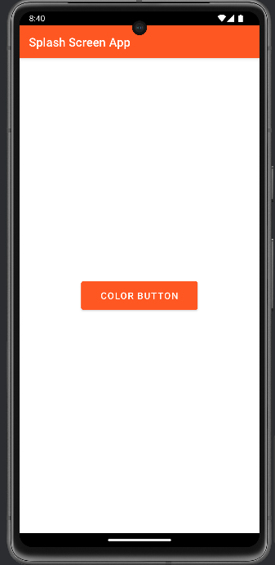  
  
  
  
  
  
  
  
  
  
  
  
  
**RESULT:**

The above program has been successfully executed.